The Sequence Experiment Instructions

Percepts and Concepts lab

This experiment has two stages. In stage I, you shall be asked to extend a sequence given the first few terms, and in the second, you will be shown a sequence, and asked to provide “another sequence like it.” Feel free to be creative in this second stage.

# Stage I: Extend a Sequence

The following screenshots demonstrate what you will see:

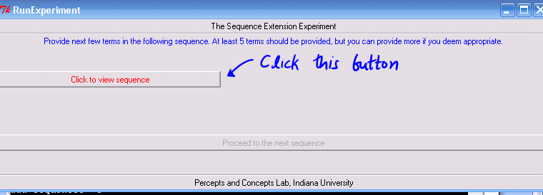

This will lead to a screen where you can see the sequence that needs to be extended:

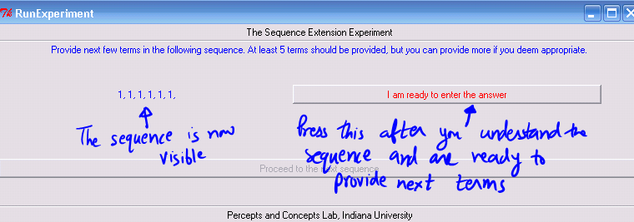

Clicking this button takes you to a screen where you can type out the answer.

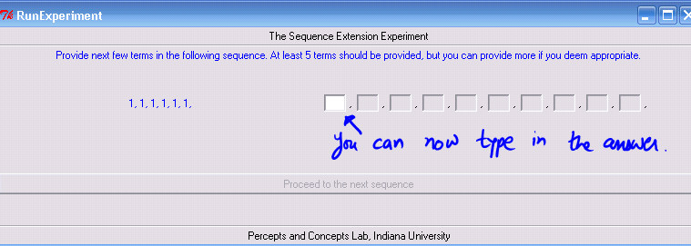

Typing in a number makes the next field visible for you to type in. When you have typed in the minimum required number of terms, the button labeled “proceed to the next sequence” becomes active. You may enter more terms if you feel that they are needed.

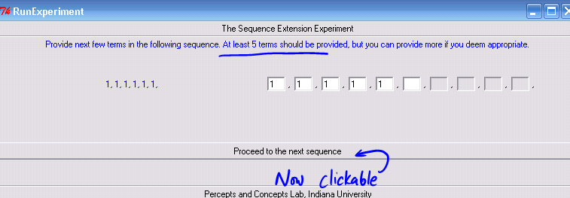

After typing a number, you can move the cursor to the next field by any of

* Pressing the Tab key,
* Pressing any letter key (‘a’ to ‘z’),
* By using the mouse.

**The first sequence you see will be a practice sequence to familiarize with the interface and will not be a part of the “real” experiment.**

**If you are unable to extend some sequence, please indicate this by using all zeros as the extension (“0, 0, 0, 0, 0 …”).**

# Stage II: Provide another sequence like

This is almost identical to Stage I in terms of the buttons that need to be clicked. The screenshots follow.

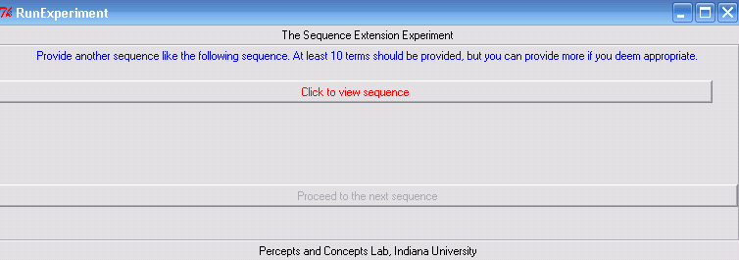

Then:

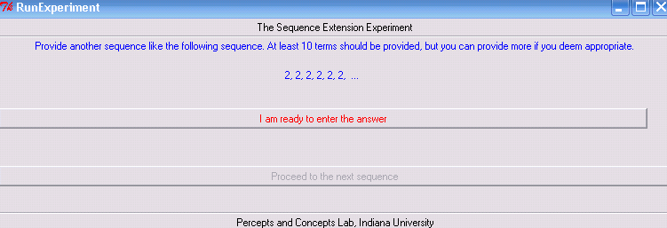

And then:

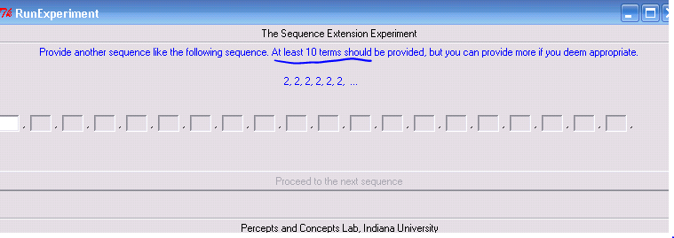

Finally:

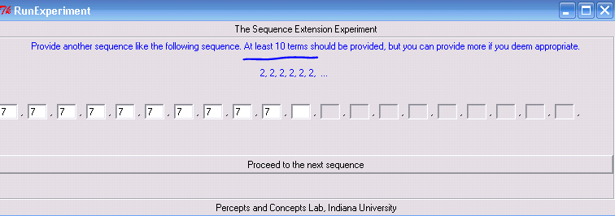

The instructions “provide another sequence like” might seem vague, and they are intentionally so, to allow you to be creative in how you interpret similarity.